UNIT 2: SCHOOL

A. VOCABULARY (TỪ VỰNG)
Lesson 1
No | Words |  | Transcription | Meaning
1 | biology | (n) | /baɪˈɒlədʒi/ | Môn Sinh học
2 | geography | (n) | / dʒiˈɒɡrəfi/ | Môn Địa lý
3 | history | (n) | / ˈhɪstri/ | Môn Lịch sử
4 | I.T (information technology) | (n) | /aɪ ’ti:/ (/ɪnfəˌmeɪʃən tekˈnɒlədʒi/) | Môn Tin học
5 | literature | (n) | / ˈlɪt.rə.tʃər/ | Môn Văn học
6 | music | (n) | / ˈmjuː.zɪk/ | Môn Âm nhạc
7 | P.E (physical education) | (n) | / piː iː /(/ ˌfɪz.ɪ.kəl ed.jʊˈkeɪ.ʃən/) | Môn Thể dục
8 | physics | (n) | /ˈfɪzɪks/ | Môn Vật lý

B. GRAMMAR (NGỮ PHÁP)
I. Using “and”/ “or” for listing
1. We use “and” to join two or more nouns in a positive sentence
I like English and music.
I like English, math and music.
2. We use “or” to join two or more nouns in a negative sentence
I don’t like English or music.
I don’t like English, math or music.

II. Possessive pronouns: mine and yours
My favorite subject is English. What’s yours?
Mine’s math.

VOCABULARY
I. Write the suitable word for each picture.
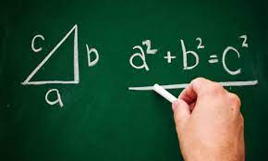 | 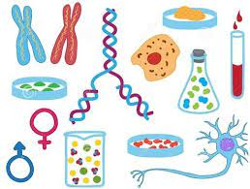 | 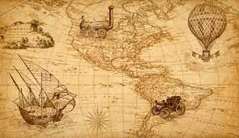
1. Maths | 2. Biology | 3. History
 | 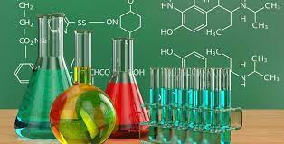 | 
4. Literature | 5. Chemistry | 6. Technology (IT)
 | 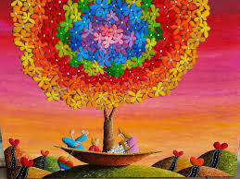 | 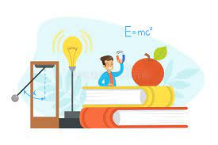
7. English | 8. Art | 9. Physics
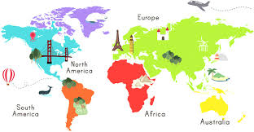 | 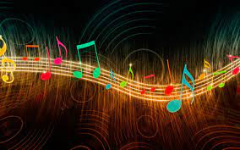 | 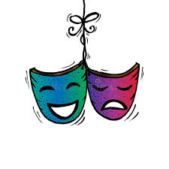
10. Geography | 11. Music | 12. Drama
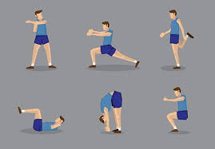 |  | 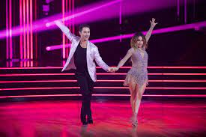
13. Physical education (PE) | 14. Science | 15. Dancing

II. Read the sentences. Circle the correct answers.
1. I like__________ because I like reading stories.
A. literature B. math C. physics D. biology
2. I like to learn about plants and how they grow. I like__________.
A. I.T B. biology C. history D. math
3. I like computers. That's why I like__________.
A. I.T B. P.E C. history D. physics
4. I love to learn about mountains and rivers. I like__________.
A. I.T B. physics C. English D. geography
5. I don't like running and playing sports. I don't like__________.
A. literature B. P.E C. math D. history
6. Studying helps me learn about countries around the__________ world and famous people in the past.
A. music B. history C. biology D. math
7. I love to learn how light, heat, and sound work. I love__________.
A. geography B. biology C. physics D. music

